Stored Procedure Exercise 1: Create a Stored Procedure
CREATE DATABASE EmployeeManagement;
GO
USE EmployeeManagement;
GO
CREATE TABLE Departments
(
DepartmentID INT PRIMARY KEY,
DepartmentName VARCHAR(100)
);
CREATE TABLE Employees
(
EmployeeID INT PRIMARY KEY,
FirstName VARCHAR(50),
LastName VARCHAR(50),
DepartmentID INT,
Salary DECIMAL(10,2),
JoinDate DATE,
FOREIGN KEY (DepartmentID)
REFERENCES Departments(DepartmentID)
);
INSERT INTO Departments VALUES
(1, 'HR'),
(2, 'Finance'),
(3, 'IT'),
(4, 'Marketing');
INSERT INTO Employees VALUES
(1, 'John', 'Doe', 1, 5000.00, '2020-01-15'),
(2, 'Jane', 'Smith', 2, 6000.00, '2019-03-22'),
(3, 'Michael', 'Johnson', 3, 7000.00, '2018-07-30'),
(4, 'Emily', 'Davis', 4, 5500.00, '2021-11-05');
SELECT * FROM Departments;
SELECT * FROM Employees;
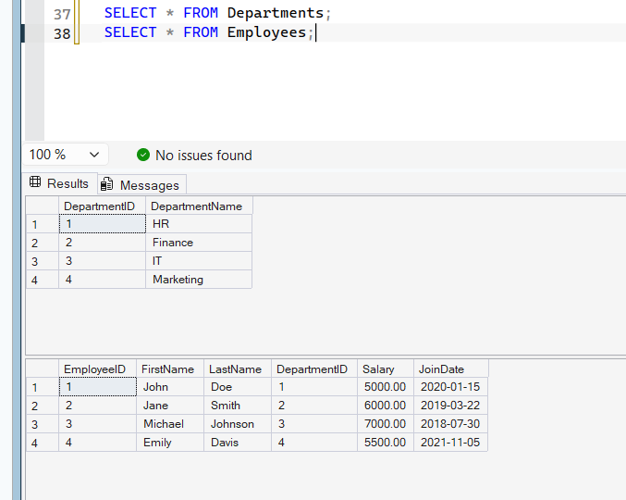

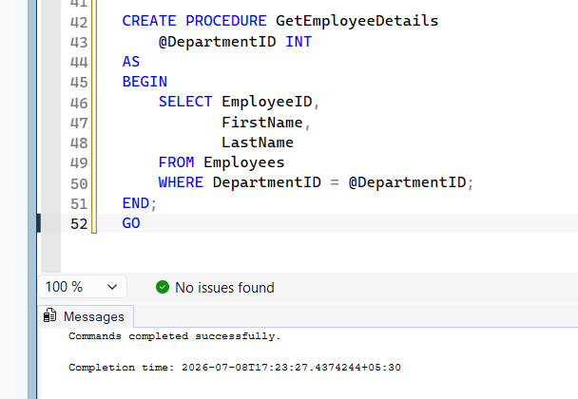

Stored Procedure

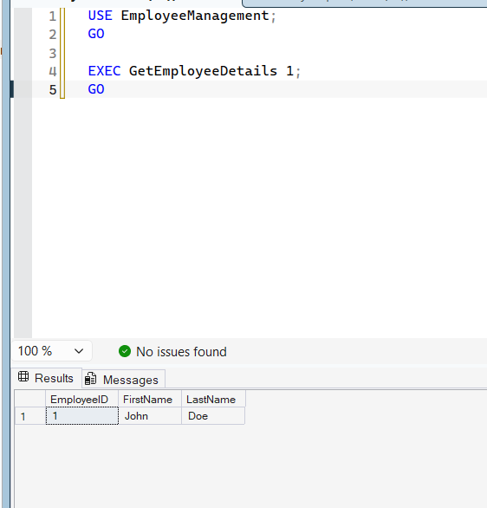

Exercise 5: Return Data from a Stored Procedure
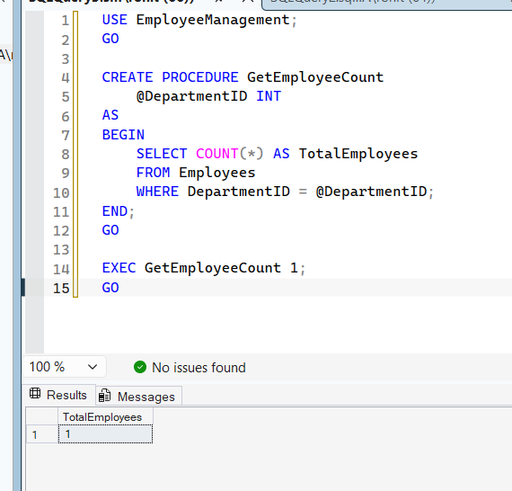

Exercise 7: Return Data from a Scalar Function

